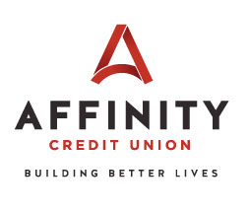
Agenda of the 2021 Affinity Credit Union Annual Meeting

- Call to Order David Busch, Chairman
- Determination of Quorum David Busch, Chairman
- Acceptance of the 2020 Annual Meeting Minutes David Busch, Chairman
- Acceptance of Committee Reports David Busch, Chairman
- Reading of the Chairman’s Report David Busch, Chairman
- Recognition of Board of Directors David Busch, Chairman
- Reading of the CEO’s Report Jim Dean, CEO
- Recognition of Affinity Credit Union Scholarship Recipients Jim Dean, CEO
- Building Better Lives in our Community Jim Dean, CEO
- Introduction of Board Nominees & Election Results Jim Dean, CEO
- Unfinished Business David Busch, Chairman
- New Business David Busch, Chairman
- Adjournment David Busch, Chairman

Following adjournment there will be a presentation of cash prizes to 8 members selected at random from a list of registered attendees.

